**Synopsis of CSE326**

**Project Name**                   **:** Salon Management System  
**Language Used                 :**  HTML, CSS, JAVASCRIPT.  
**User Interface Design     :**  HTML,CSS,JAVASCRIPT  
**Web Browser                     :** Mozilla, Google Chrome, IE8, OPERA  
**Software use                      :** visual studio, notepad++,notepad,Xampp.   
In this project we use HTML, JavaScript and CSS. it is based on following moduls

***Brief description of the modules*  
 #.** Name of the salon is **Beautify**   
**#.** then you put a comment “our Happy customers”.

**#** Then you insert various types of images which will move like

**User can see the ----**   
**0. Home Page**: Users can take appointments with salon on particular date and time.  
**0. Services**: User views the services which is offer by salon.  
**0. About Us**: User sees the details of salon.

**0. Book online:** User can booking a slot.

User can see the booking rate for various thing also—

* For facials – under 1000, 2000,3000
* For makeup – under 1000, 2000,3000
* For nails- under 1000,2000,3000

**0. Contact Us**: User can contact to salon.

**0. Special Days:** User can booking for special days like weeding, a particular season special, ect Special Days.

**#.** User can also see beautify facebook, Twtter, and Insta account. Link is given in the home pages

***Name of the group members:***

1. **Dipraj Daripa (reg no. 11911828)**
2. **Alok Raj (reg no. 11908545)**
3. **Ajeet kumar (reg no. 11908473)**

***Work plan and gntt chart:***

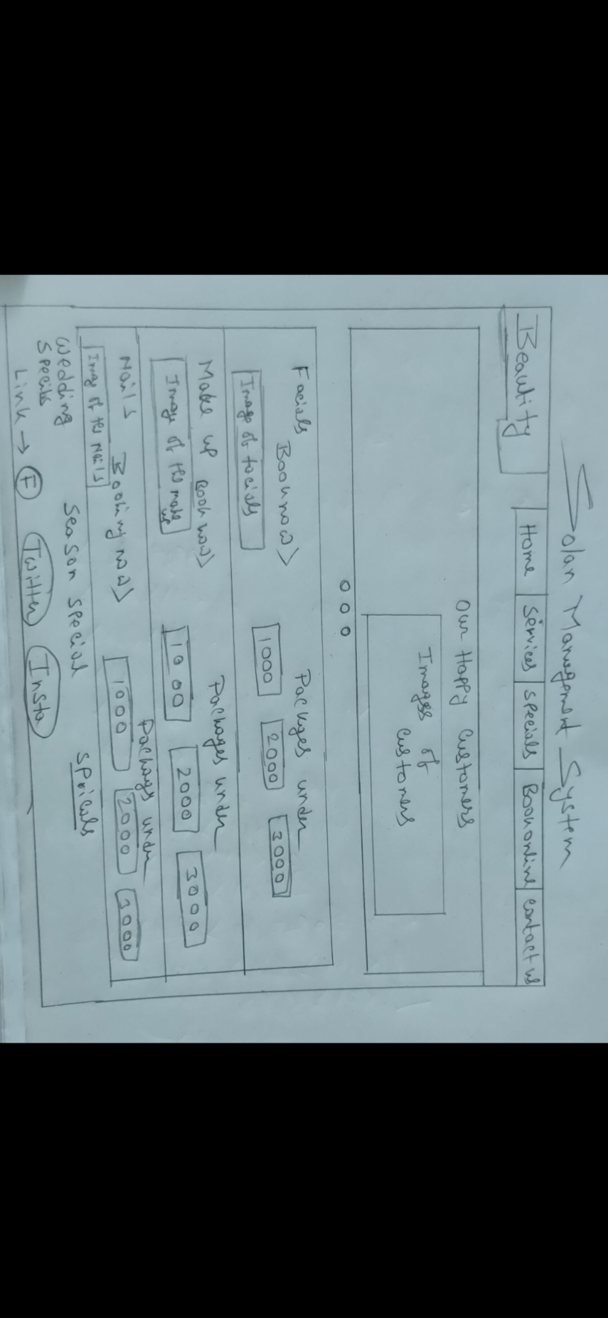

**Submitted to:** Manu Bali